Screen Connect
Screen Connect is a tool used to remotely access a customer’s computer for support purposes. These are instructions to guide you through how to allow TaxSlayer Books to help you through remote connection.
Enter http://Connect.CloudTaxOffice.com into the address bar of your browser. A link to this address can be found on our support page, or inside the program under “Quick Links” on the sidebar.
When the Welcome screen appears, enter the Connection Code and click Join.
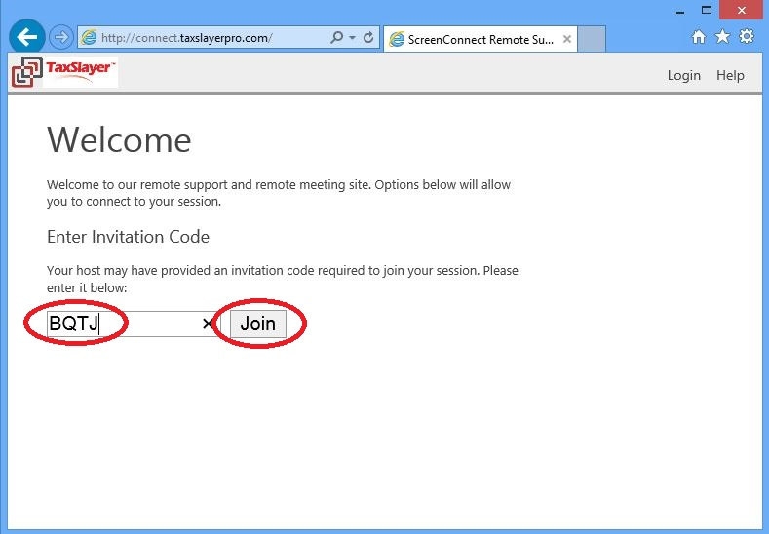
If you receive a security prompt, click Run.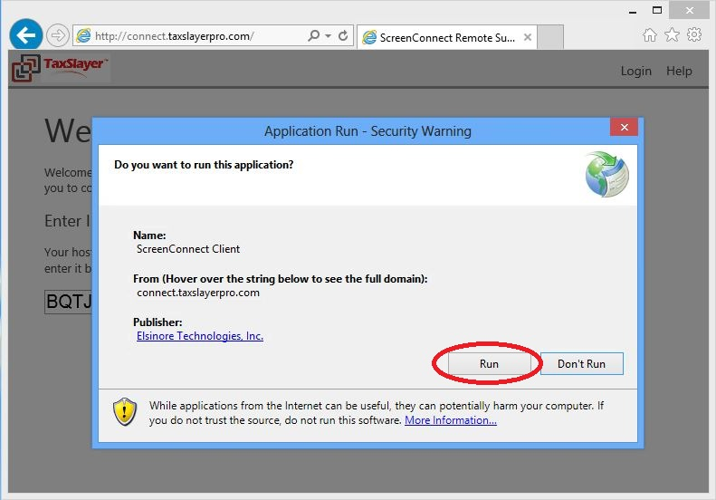
The following will be displayed on your computer as the session is created.
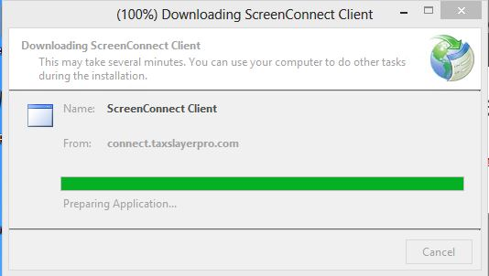

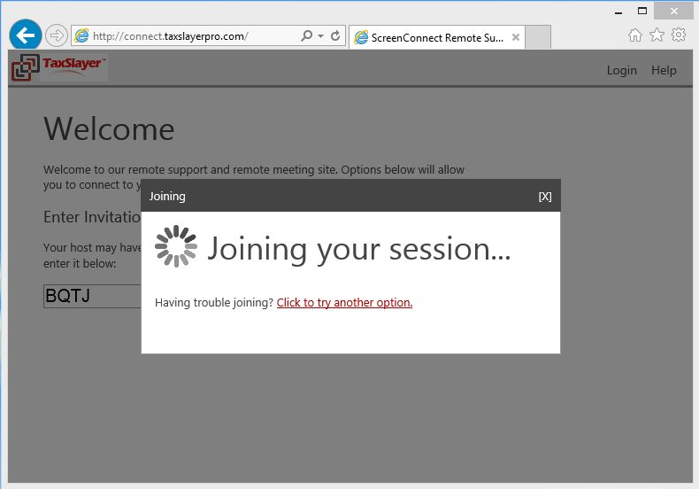
Once the session has been created, the following window will appear on your computer.
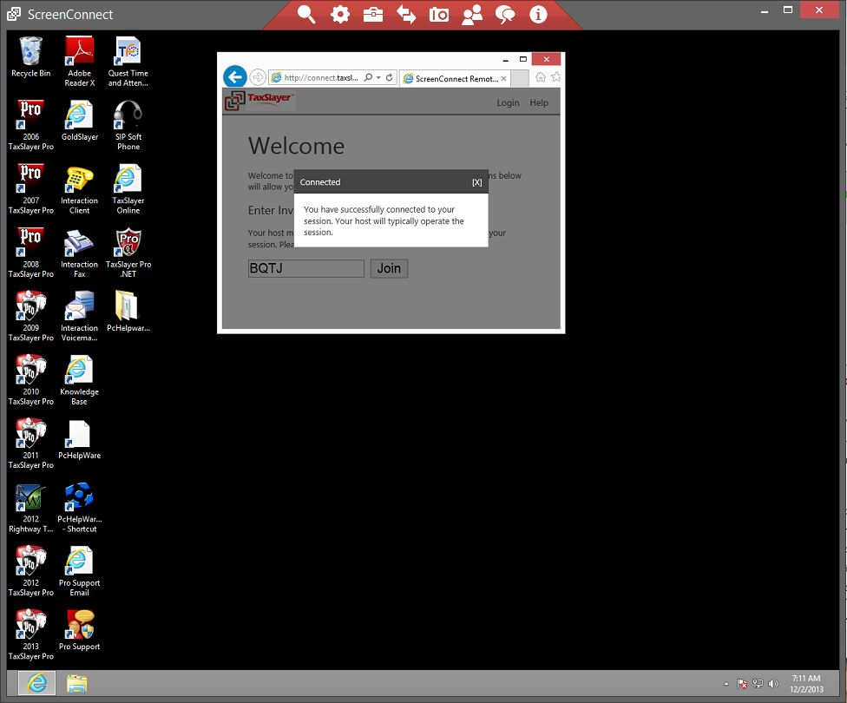

You have now successfully connected to a support session. Once your issues or questions have been resolved you can close the session and exit from your browser.

